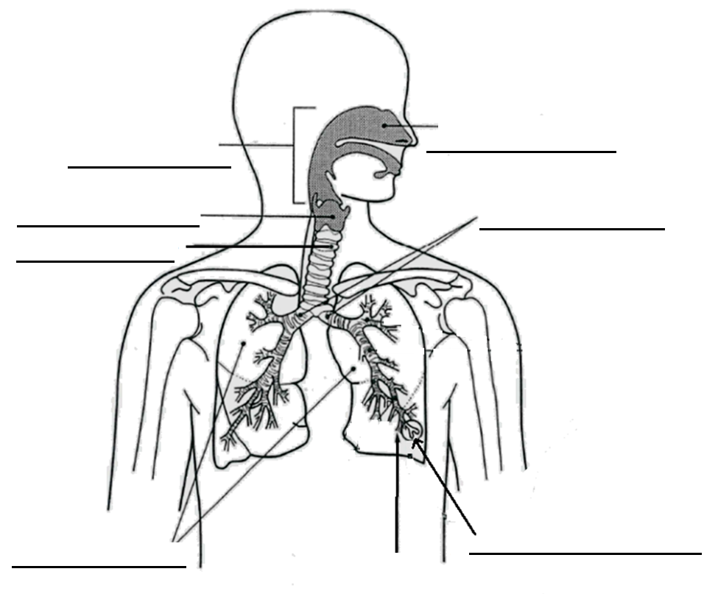
RESPIRATORY SYSTEM Name: ________________________________
Respiration is the breakdown of sugar in oxygen to give energy.
Breathing brings oxygen from the air into our blood.
We use our respiratory system to breathe.

Glucose + _______________ Carbon Dioxide + _____________ + Energy
Air comes in through the ____________ passage.
The air then moves through the pharynx (throat) and then the larynx (voice __________).
The air moves through the _________________. This has rings of cartilage to stop it from collapsing in on itself.
The trachea branch into two _____________. These then branch off into even smaller branches called __________________________. At the end of these small branches are tiny bubbles of air called _____________________.

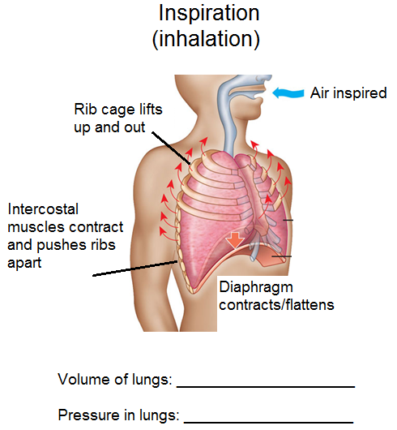

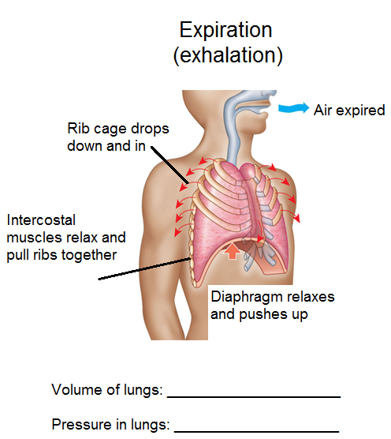

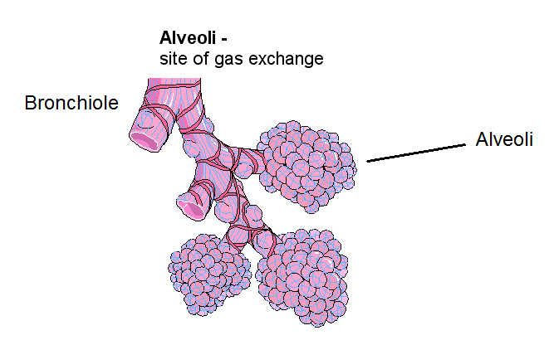
GAS EXCHANGE
This occurs in the alveoli of the lungs.
Oxygen in the alveoli is exchanged for carbon dioxide in the blood.
Air that has been inspired has a higher concentration of oxygen and a lower concentration of carbon dioxide.
Blood which has travelled around the __________ has used up the oxygen so there is a _____________ concentration of oxygen and a higher concentration of carbon dioxide.
The blood that moves through the capillaries and around the alveoli collects oxygen and it is taken to the rest of the body.
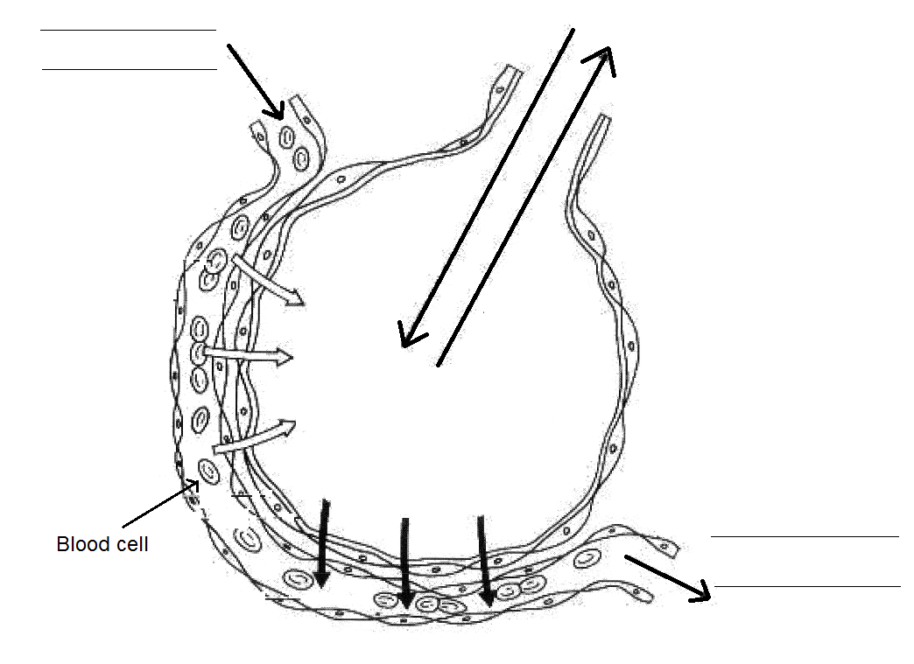
These gases are exchanged through a process called diffusion.

RESUCITATION
Breathing into the _____________ or nose of the patient to keep up the ________________supply to their cells.

EXCRETION
Wastes are removed from your body through sweating, urinating, __________________ out and defecation (doing a number 2).
The process of removing _____________ from the body is called excretion.

Urination
Your body has ________ kidneys.
The waste from your body cells is carried in the blood to your kidneys which then filter the blood and remove the wastes.
Each kidney is about ______ centimetres long and contains many microscopic structures called __________________.
Wastes such as urea, _____________ and excess water (extra water that your body doesn’t need) are removed.
The waste leave the kidneys through two tubes called ________________.
It is then stored in the bladder. The liquid is now called _________________.
When the bladder becomes full, the liquid leaves the body through a tube called the urethra and urination has occurred.

Sweating has two main functions.
It helps to control your body _____________________.
It removes waste water containing ______________.

Defecation is when undigested food and dead blood cells leave your body through the anus. This waste is called f_________________.



